**Mobile restaurant booking system**

**Cloud tables operation - A desktop computer system for system operators to perform operations across restaurants.**

**TASK 2 - ANALYSIS AND SPECIFY SOFTWARE QUALITY REQUIREMENTS**

In this task , each member will work as a requirements analyst to produce a document that defines the quality requirements on your subsystem. The definition of quality requirements should clearly specify the requirements on the following quantity attributes

* Security and Privacy protection
* Performance
* Reliability
* Scalability

**Security and privacy protection**

System operators are responsible for overlooking the chains of restaurants, viewing system data , statistical operations and ensuring that systems are active/deactive for specified restaurants. Systems should be reliable with 99.9% uptime as well as providing information to restaurants on how to improve and what customers have said about their experiences.

Security and privacy is important in ensuring competitors do not access company data , but also in the sense that customer details such as bank details , receipts and confidential data are not intercepted or leaked in any way. The operations team should have the following implemented in order to mitigate any risks:

* The system should have some form of authentication which provides different access levels , such as system administrators should have access to whole operations whereas employees who deal with basics would only have access to the dedicated operations.
* The system should use security features such as firewalls in order to log any access attempts to data. This is required as those in operations will have access to customer data , and activation and deactivation of restaurant accounts. Having these protected is crucial as it ensures restaurants receive a good up time as well as no issues , alongside customer data being protected which abides with data protection acts , and GDPR .

**Performance**

**Response to operations member :**

The system needs to be kept updated in order to provide and filter information and also enable the operation team to update menus,events and customer information. Databases and servers should be accessible by anyone with authority and should support multiple concurrent operations taking place across all the restaurants.

**Resource availability :**

The system should be able to take on heavy loads such as cpu and memory utilisation , this is necessary during peak business hours when data is being copied back to the databases to be filtered by the system and operations team.

**Reliability**

Reliability is important for a system that overlooks multiple restaurants with most systems offering 99.9% uptime. This is necessary because restaurant chains will be dealing with a vast quantity of customers over the same period. The system needs to maintain uptime so restaurants can check customers in and out , deal with quantity checks and communicate with other restaurants across the chain. Uptime is also important for the operations team so they can monitor and analyse the restaurants under their corporation , they can support managers with any queries and complaints as well as providing information back to each restaurant. The system should make use of the following procedures :

* The system should be able to handle errors and have a fallback mechanism where if something goes wrong then it can reroute and still provide a service.
* Backups of databases so should any incidents or data loss occur they can be recovered through backups.

**Scalability**

The system should be able to handle large volumes of data and handle the expansion of chains that are linked to the database. The system should be designed in such a way that more hardware and software can be added to it as well as being ready for the future so that additional resources can accommodate new implementations.

* The operations team is responsible for having an application that allows customers to join and share their experiences Through social networking. The system should be able to accommodate new and existing members who have signed up to the social network and application. This is important as it allows the operations team to see what customers post as well as enabling them to take on any feedback .
* The system should be capable of distributing traffic equally across given resources , this should come effective during times of peak performance as well as times where new software is added to the system.

**Task 3**

**Task 3B** 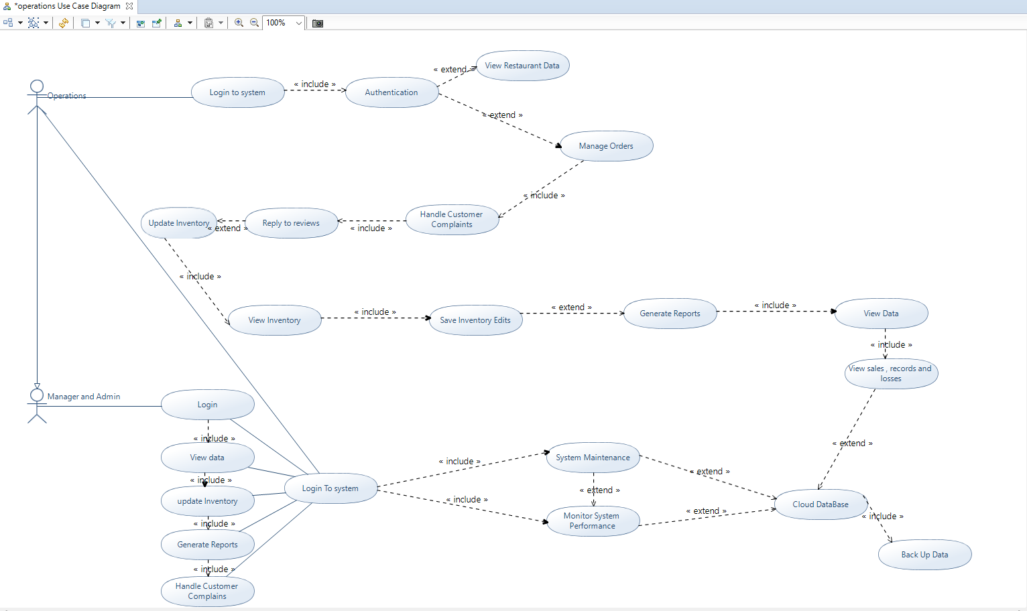

Activity model

Use Case Model : Customer feedback system

Actors: Operation administrators , managers and administrators

Theory: The system admin overlooks all factors that make up the restaurant's systems , enabling access to managers.

Entry condition ; The operations admin has logged into the system

2

Exit Condition : The operations admin has submitted data to the cloud database after making amendments and it has been backed up.

Flow of events:

1. The customer provides feedback through the restaurants social media platform
2. The system uploads this to the database but it's also viewable by administrators and managers
3. Admin logs into the system and authenticates themselves
4. The admin clicks on manage order to view customer orders and sub sections
5. The admin has the option to view customer complaints and reviews
6. The system offers the admin to be able to reply to these reviews
7. The system is then updated and backed up

Managers

1. Managers have to log into their own system.
2. The system gives the option to view data which splits into subsections
3. The manger can generate reports
4. The manger can then handle customer queries
5. Once the manager saves the response it's updated in the database and on the social media app.

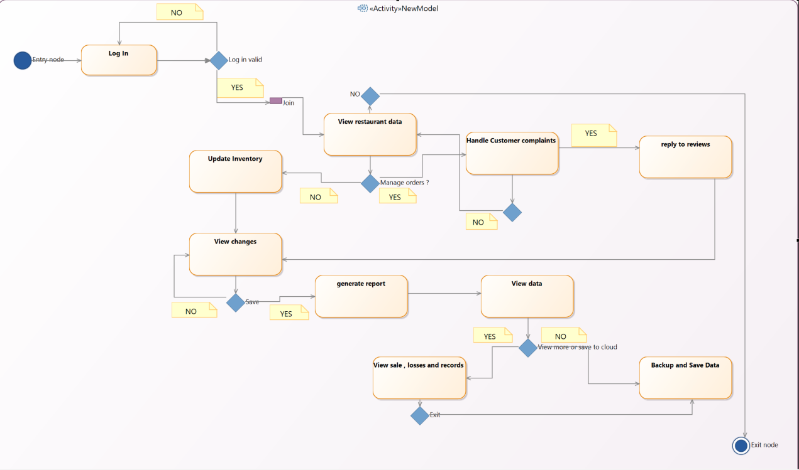

Task 4A :

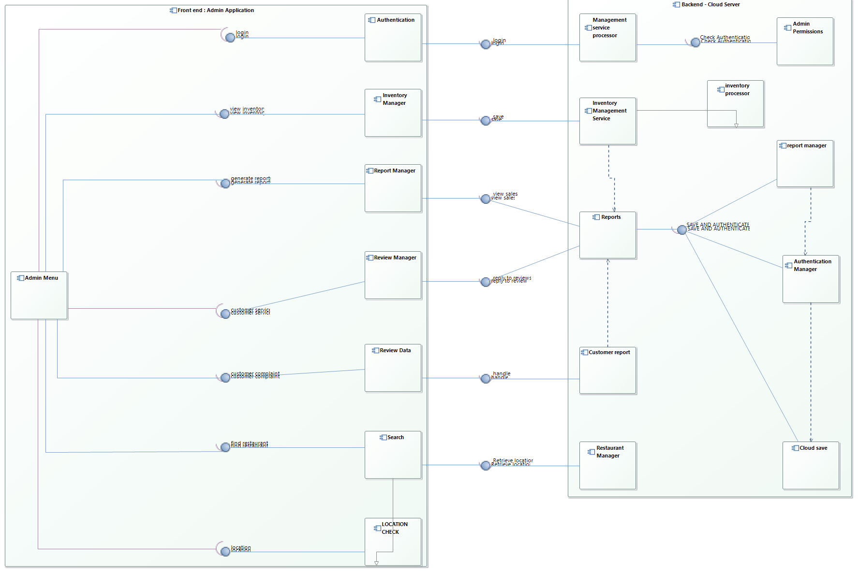

Task 5A :

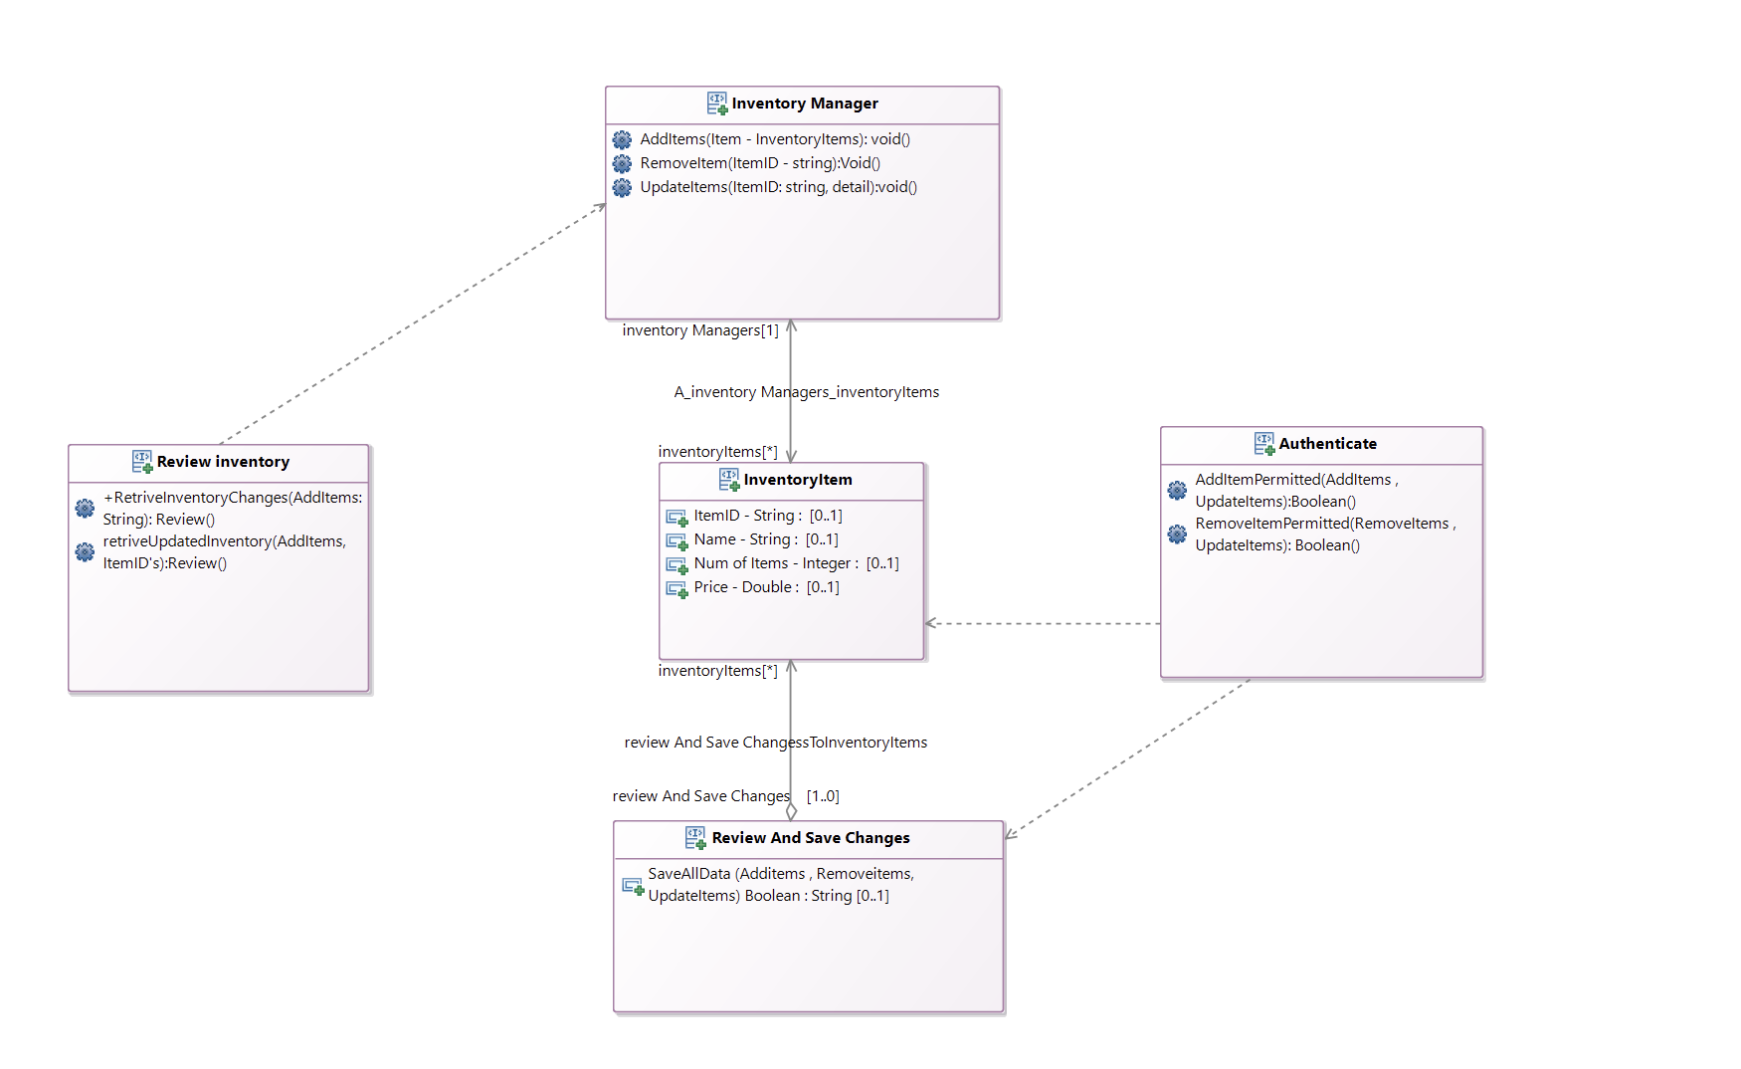

Task 5B:

